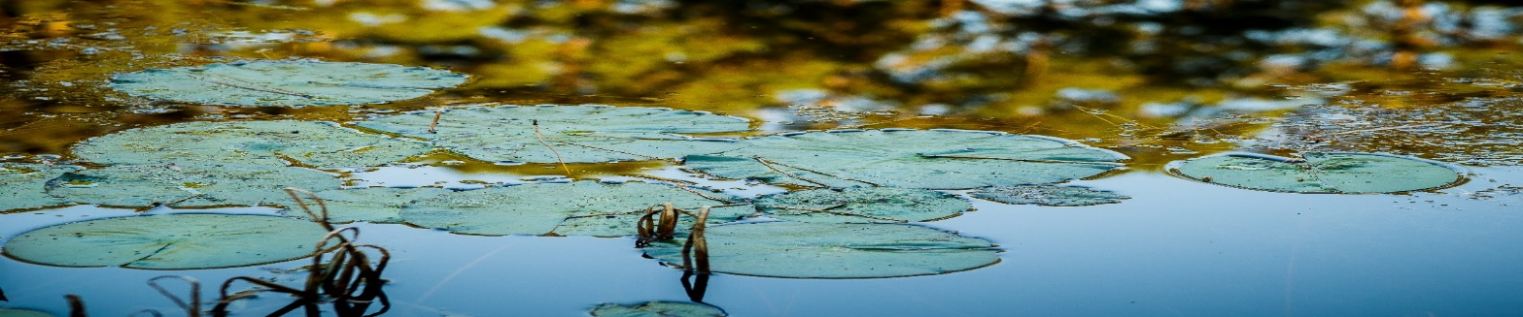
Texas Watershed Coordinator Roundtable - Agenda

October 21, 2020 | 9:30 a.m. – 12:00 p.m.
Virtual Roundtable
9:00 a.m. Registration

9:30 a.m. Welcome, Introductions and Tour
Clint Wolfe & Fouad Jaber, Texas A&M AgriLife

11:30 a.m. Agency Updates, Panel Perspectives and Discussion
Moderator: Lucas Gregory, TWRI
Panelists: Mike Bira, EPA
Faith Hambleton, TCEQ
TJ Helton, TSSWCB

12:00 p.m. Catered networking lunch (or bring your own) [RSVP required]

1:00 p.m. Communicating Watershed Plans to Elected Officials
Mary Luedeker, Texas A&M AgriLife

1:30 p.m. Break

1:45 a.m. North Texas Watershed Updates and Panel Moderator: Lucas Gregory, TWRI
Panelists: Tina Hendon, Tarrant Regional Water District
Galen Roberts, North Texas Municipal Water District
Aaron Hoff, Trinity River Authority

3:15 p.m. Wrap-Up
Nathan Glavy, TWRI
- Upcoming Trainings
- Next Roundtable – January 2020 –TBD
The Texas Watershed Planning Program is managed by the Texas Water Resources Institute and is funded through a Clean Water Act Section 319(h) nonpoint source grant provided by the Texas State Soil and Water Conservation Board and U.S. Environmental Protection Agency.

9:00 a.m. Event Sign In Online

9:30 a.m. Welcome, Introductions and Round Table Overview
Dr. Lucas Gregory, TWRI

9:45 a.m. Panel: Engaging Volunteers to Enhance Impact – Experiences From Three Established Programs
    - Dr. Lisa Whittlesey – National Junior Master Gardener
    - Michelle Haggerty / Mary Pearl Meuth – Texas Master Naturalists
    - Melissa Felty (Alderson) – Texas Parks and Wildlife Water Specialists

11:00 a.m. Facilitated Q&A with Volunteer Engagement Speakers

11:30 a.m. Federal and State Agency Updates
- Continued COVID-19 Implications to Programs and Contracts

11:55 p.m. Wrap-Up & Program Evaluation
Nathan Glavy, TWRI
- Next Roundtable – April 2021 –TBD

The Texas Watershed Planning Program is managed by the Texas Water Resources Institute and is funded through a Clean Water Act Section 319(h) nonpoint source grant provided by the Texas State Soil and Water Conservation Board and U.S. Environmental Protection Agency.

